Project milestone 2

Data and persistence baseline:
The purpose of this section is to convert approved M1 requirements into a structured format for managing information related to service requests. It centers on the core service-request lifecycle, covering aspects such as submission, categorization, assignment, status tracking, history, feedback, accountability, and management reporting. This document will serve as the foundational baseline, with potential for further attributes and constraints to be integrated during implementation as new evidence or requirements emerge.

Initial data model:
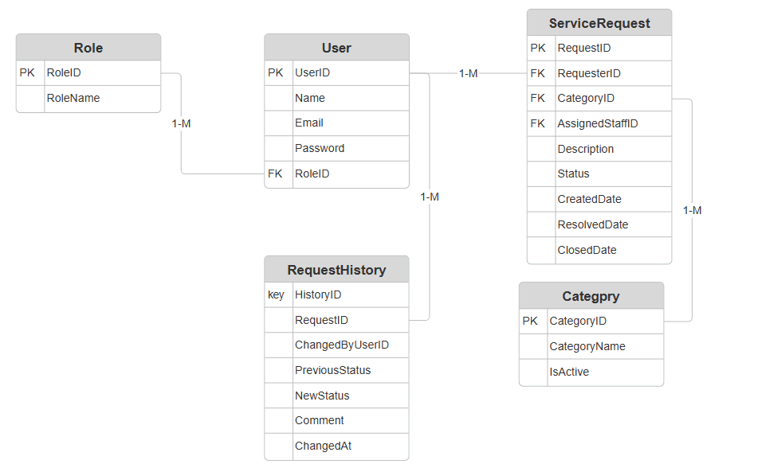

Entity relationship:
Relationship | cardinality | Reason
Role to User | 1:M | One role can apply to multiple users.
User to ServiceRequest(requester) | 1:M | A requester can submit multiple service requests
Category to ServiceRequest | 1:M | A category can contain multiple service requests
User to ServiceRequest(assigned staff member) | 1:M | A staff member can be assigned multiple service requests
ServiceRequest to RequestHistory | 1:M | A request can have multiple history entries
User to ServiceRequest | 1:M | A user can make multiple recorded changes

Ownership:
Entity | Lifecycle
Role | Controlled reference data which will be managed by authorized administration
User | Represents an account along with its assigned role
Service Request | Functions as a central business entity with a lifecycle from submission to resolution.
Request History | Dependent on service requests and tracks changes throughout its lifecycle.
Category | Controlled reference data which will be managed by authorized administration

Persistence decisions

Requirements driving the persistence decision:
The M1 baseline is the source of the following requirements
- Organized connections between users, requests, history, and categories
- Distinct identifiers for service requests
- Regulated categories
- Lifecycle and status tracking
- Auditable history
- Role-based access
- Dependable storage
- Management reporting
- Request filtering by category/status
- Atomic creation and modification of request data
- Protection of sensitive data
- Potential expansion
The team considered the following alternatives:

Relational database(such as PostgreSQL, MySQL, SQL server):
The advantages are as follows:
- Structured schema
- Foreign-key relationships
- Referential integrity
- Constraints
- Transactions
- Appropriate for request/history relationships
- Appropriate for managing reports and queries

Document database(MongoDB):
The advantages are as follows:
- Adaptable document structure
- Simple document shape modification
- Appropriate for applications where data is inherently document-oriented

Recommended decision:
The recommended persistence method for CivicConnect is relational persistence. The organized relationships and integrity constraints mentioned in M1 are a perfect fit for a PostgreSQL relational database.
PostgreSQL transactions are made up of multiple SQL statements which are combined into a single, atomic unit of work. This process protects the database from incomplete data changes and corruption by guaranteeing that either all operations are fully successful or none of them take effect (PostgreSQL, 2026). Within PostgreSQL foreign-key constraints connect two tables and maintain referential integrity. It guarantees that a value in a child table’s column corresponds to a value in a parent table’s main key or unique column. PostgreSQL offe3rs two core methods for backing up data, namely, logical and physical backups. Physical backups duplicate the actual data files that PostgreSQL uses, whereas logical backups generate SQL statements that can replicate your database’s structure and data (Pawale, 2026).
Overall, PostgreSQL was chosen over the other relational database systems because it satisfies CivicConnect’s anticipated data and reporting requirements while offering the necessary relational features, robust referential integrity, transaction support, and dependable backup capabilities. It also proved to be the more sensible option for the project’s development and deployment requirements because it is open-source and does not require licensing.

Data integrity and transaction decision:
Upon receiving a service request the system must generate the following:
- The service request
- Its original status
- The creation date
- Relevant metadata
- And its initial requestHistory record.
The appropriate manner to handle these activities it to treat them as a single business activity. CivicConnect may have an unfinished audit trail if the request is created successfully but its original history is not documented.
The validation responsibilities for the system must be separate. The UI must be utilized for basic input validation, the service/business layer for handling business rules and transactions, whilst the database manages structural constraints and integrity of data.

The proposed flow should be as follows:
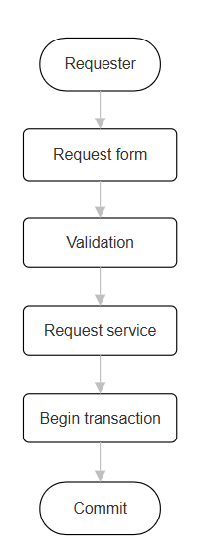

Technology stack:
For CivicConnect, the chosen technological stack is made up of C# with ASP.NET Core for the backend and application runtime, React for the frontend and PostgreSQL for persistence. The Npgsql PostgreSQL supplier will supply the application-to-database data access layer for Entity Framework Core. Automated unit testing will be done with xUnit, and build and test automation will be provided by GitHub actions. The M1 requirements for role-based access, service request management, status/history monitoring, auditability, reporting, data integrity, and maintainability are all supported by this stack.

Area | Selected technology | Reason
Frontend | React framework | CivicConnect requires several interactive views for requesters, staff, management, and administrators, including service-request forms, status updates, filtering, request history, and management reports. React was chosen because these interfaces can be created as reusable components thanks to React’s component based architecture, which promotes consistency and maintainability throughout the application.
Backend | ASP.NET core MVC/C# | This decision offers an organized application architecture that can be used to divide persistence, business logic, and presentation. Additionally, CivicConnect’s requester, staff, management and admin roles are directly supported by ASP.NET Core’s built-in authentication and authorization features.
Persistence | PostgreSQL | The structured relationships between users, roles, categories, service requests, and request history in CivicConnectare best served by a relational database. Data integrity may be maintained via PostegreSQL’s constraints and transaction features.
Data access | Entity framework core + Npgsql | Reduces the amount of database-access code that needs to be written by hand while offering PostegreSQL a data-access layer that is compatible with .Net.
Testing | xUnit | Offers a simple framework for automated business logic and service unit testing.
Build management | .NET SDK+ NuGet | This choice gives the chosen C#/.NET stack a standard build and dependency-management procedure. Through the project settings, dependencies can be reliably restored and version pinned.
CI | GitHub actions | It can automatically build and test pull requests, giving visual verification results prior to merging, and it works with the team’s current GitHub workflow.
Deployment | ASP.NET Core + PostgreSQL | Instead of relying on a proprietary database or specialized runtime, the chosen technologies can be deployed as a conventional ASP.NET Core web application with a PostgreSQL database.

Comparison project constraints:
CivicConnect’s functional requirements, team competency, timetable, and budget constraints were taken into consideration when choosing the technology stack. The interactive role-specific interfaces needed for M1, such as request submission, status viewing, filtering, and management dashboards, are supported by React. A structured backend for business logic, authentication, and role-based access control can be implemented using C# and ASP.NET Core. PostgreSQL was chosen because CivicConnect has data-integrity standards and defined relationships, and its open-source licensing eliminatwes the need for additional database licensing fees. Development and dependency risk are also decreased by using well-known tools like Entity Framework Core, Npgsql, npm and NuGet. Lastly, the technologies may be connected with GitHub actiosnand the team’s current GitHub process, making the stack feasible to develop within the project’s timeline.

Version, compatibility and security assumptions:
The project will employ PostgreSQL 18 for persistence, React 19 for the front end, and.NET 10 or ASP.NET Core 10 for the back end. While Entity Framework Core with Npgsql will enable compatibility between the.NET application and PostgreSQL, frontend and backend dependencies will be managed by npm and NuGet, respectively, with versions documented in the project files to guarantee consistent development environments. The frontend and backend will communicate via HTTP-based APIs.
Throughout development, compatible stable versions and security updates will be implemented. While input validation, parameterized database access, and PostgreSQL constraints will be utilized to lower common data and injection threats, ASP.NET Core will manage authentication and role-based authorization. Additionally, the group will steer clear of superfluous dependencies and check dependency updates for security and compatibility issues before adoption.

Decision and risk management
An Architecture Decision Record (ADR) will document the chosen technology stack and the alternatives taken into consideration, along with the rationale behind each technology's selection and the pertinent compatibility assumptions. Risks including team familiarity, dependency compatibility, security flaws, and deployment concerns will be addressed by updating the project risk registry. During development, any major modifications to the technology stack will be compared to the initial specifications and recorded in a revised ADR.

Technology Architectural Design Record’s:

ADR-001: React frontend
CivicConnect necessitates a flexible web interface that supports various roles and interactive features, such as staff assignment, management reporting, status viewing, request history, and service request submission. Therefore, maintainability and reusable user interface components must be supported by the frontend technology while staying within the team’s development timeline and skill development.
Frameworks considered:
- Blazor
- Plain Html/CSS/Javascript
- Angular
- React
- Other frameworks used for frontend
Decision:
React was chosen because interactive role-specific interfaces and reusable UI components are supported by its component-based architecture. It offers CivicConnect enough capability without necessitating the intricacy of a more elaborate application architecture.

Positive outcomes:
- Reusable components
- Ideal for dashboards and interactive forms
- Extensive documentation and ecosystem
- Keeps backend AP and frontend duties separate.
Negative outcomes:
- Adds more dependencies than just basic Javascript
- Calls for team to learn more about npm and react.
Risk:
Maintaining compatible React and npm dependencies is essential, as is checking major dependency updates for compatibility or security flaws.

ADR-002: C#/ASP.NET Core backend
For the administration of service requests, status changes, authentication, role-based access control, validation, and database interaction, CivicConnect needs backend business logic. In addition to being appropriate for the team's skills and project timeline, the backend must provide a maintainable architecture.
Frameworks considered:
- C#/ASP.NET Core
- Node.js / express
- Other server-side frameworks
Decision:
Because it offers an organized framework for executing the application's business logic, authentication, and role-based authorization, C# with ASP.NET Core was chosen. Additionally, it has direct integration with PostgreSQL and Entity Framework Core.
Positive outcomes:
- Durable business logic framework
- Supports role-based access control and authentication
- PostgreSQL with Entity Framework core integration
Negative outcomes:
- Requires familiarity of the .Net ecosystem
- Greater structure within the framework than a basic Node.js/Express program
Risk;
The project is contingent on the chosen versions of Entity Framework Core, Npgsql, and.NET remaining compatible during development. Dependency versions will be controlled, and major updates will be reviewed before adoption because updates to these dependencies may cause compatibility problems or necessitate code changes.

ADR-003: PostgreSQL Relational Persistence
Using M1 data-integrity needs and structural relationships between entities like Users, Roles, Categories, Service Requests, and Request History were identified. Reliable reporting, transactions, and referential integrity must all be supported by the persistence system.
Databases considered:
- PostgreSQL
- MySQL
- MongoDB
Decision:
CivicConnect's structured relationships make PostgreSQL an excellent choice for relational persistence. In order to preserve consistent data, PostgreSQL offers transactions, foreign-key restrictions, and other database constraints. Additionally, it saves additional database licensing fees because to its open-source licensing.
Positive outcomes:
- Strong integrity between relationships
- Supports transactions
- Ideal for structured queries and reporting
- No extra fee for database licensing
- EF core compatibility via Npgsql
Negative outcomes:
- Requires well defined schema for relationships
- Migrations must be used to handle schema changes
Risk:
The chosen PostgreSQL version must continue to work with the database schema and migrations. Entity Framework Core and the Npgsql provider will be used for database access.

Updated RTM
Requirement | Persistence impact | Design | Technology | Implementation evidence | Verification
FR-001 | ServiceRequest + initial RequestHistory | Request creation service | React + ASP.NET Core + PostgreSQL | Endpoint + models | Planned
FR-002 | Category FK | Controlled category entity | ASP.NET Core + PostgreSQL | Category model and schema | Planned
FR-003 | RequestID PK | Unique request identifier | PostgreSQL + EF core | Schema/model | Planned
FR-004 | ServiceRequest.Status | Request retrieval | React + ASP.NET Core + PostgreSQL | Status endpoint | Planned
FR-005 | RequestHistory | Request history relationship | React + ASP.NET Core + PostgreSQL | History model | Planned
FR-006 | RequestHistory | Status-change handling | ASP.NET Core + PostgreSQL | Status service | Planned
FR-010 | AssignedStaffID | Assignment responsibility | React + ASP.NET Core + PostgreSQL | Assignment endpoint | Planned
FR-011 | Status + RequestHistory | Controlled status transition | ASP.NET Core + PostgreSQL | Status service | Planned
FR-012 | RequestHistory | Action/comment recording | React + ASP.NET Core + PostgreSQL | History model | Planned
FR-014 | RequestHistory | Management activity query | React + ASP.NET Core + PostgreSQL | Management query | Planned
FR-015 | Status + dates | Reporting queries | React + ASP.NET Core authorisation+ PostgreSQL | Reporting API | Planned
NFR-019 | User/Role + access rules | RBAC architecture | ASP.NET Core + PostgreSQL | Role implementation | Planned
NFR-020 | RequestHistory/audit data | Audit trail | ASP.NET Core + PostgreSQL | History implementation | Planned
NFR-022 | Persistent ServiceRequest | Transaction persistence | PostgreSQL + EF core | Migration + transaction logic | Planned
NFR-024 | Database/application response | Performance-aware architecture | React + ASP.NET Core + PostgreSQL | Query/API implementation | Planned

